These are some general directions on how to graph your Haltech Datalog in Microsoft Excel. If you have any problems or questions feel free to e-mail me at mailto:moreiraeric@usa.net .

Step 1:

I cannot take a screen capture of the E6K so these will only be typed instructions. With the datalog on the screen, hit “P” and it will bring up the print option. Select print to file by hitting “F” and then you will be prompted to enter a file name, name it as appropriate. Hit “Enter” and it will prompt you to select which pages to print. This is where some Haltech will crash if you choose too many pages and I am not sure how to fix that right now. Select the beginning page and hit “Enter” and then select the ending page and hit “Enter.” It will now ask if your printer is hooked up. Even if you have no printer hit any key because it is printing to file.

Step 2:

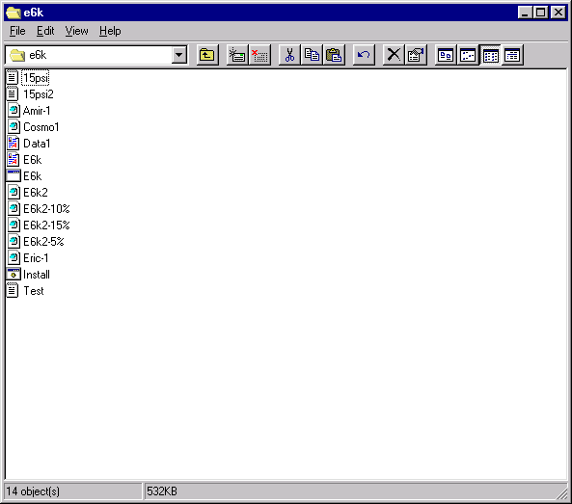
Now find the location of the .txt (Text) file and double click on it. Mine was named “Test”

Step 3:

You will get something that looks like this:
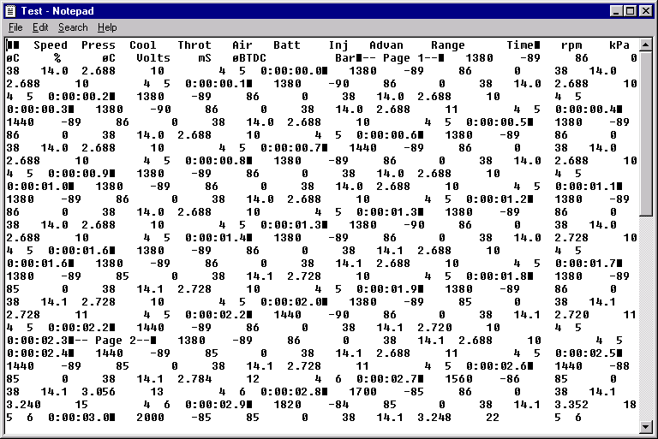
This is the raw data from the datalog that we will have to resize. What you will need to do is drag the right side of the window until it looks like step 4. When you first open the window, it will be too big so if you slowly move JUST the right side so it gets smaller it should begin to resemble step 4.

Step 4:

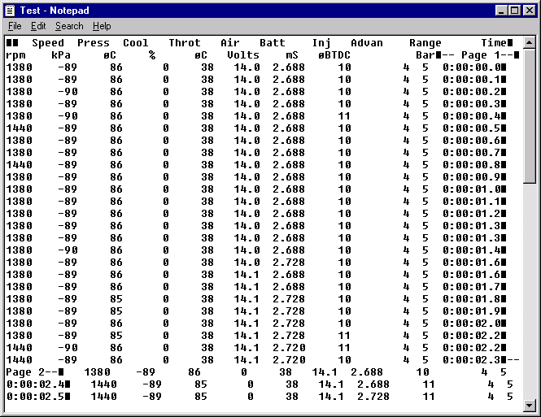
It should look like this. Now you will have to go and manually delete the page numbers so they all line up like in Step 5.
Step 5:

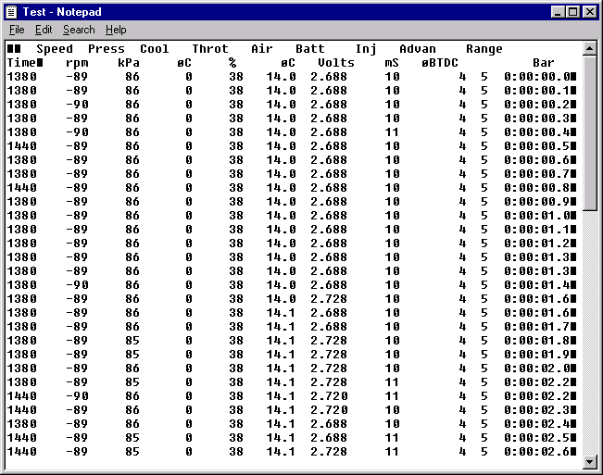
They are all nicely lined up now. Save it and then click “Edit” and then “Select All” and then “Edit”, “Copy” or whatever shortcut you normally use.
Step 6:

Now open up Microsoft Excel and make sure you have a new sheet. Now click “Edit” and then “Paste” and you should have something like this:
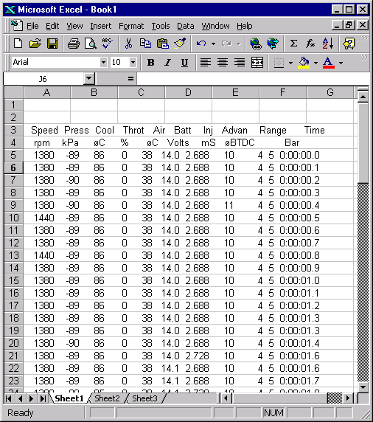
You may have to do a little editing to get it right but nothing too hard.
Step 7:

Now select just the first column of data, from the first row with numbers to the last row.
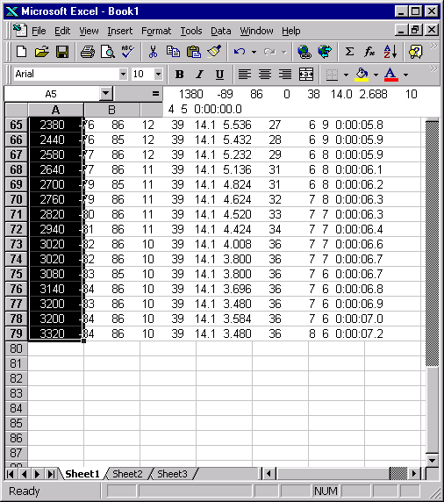
There is the highlighted text.
Step 8:

Click “Data” and then “Text to Columns…”
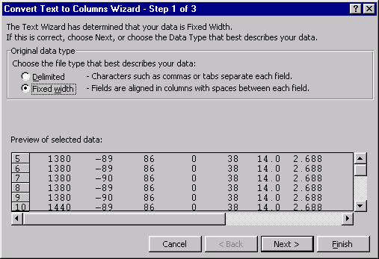
Click “Next” 2 times and then “Finish.” It will automatically section apart the numbers if they are lined up well and it should look like this:
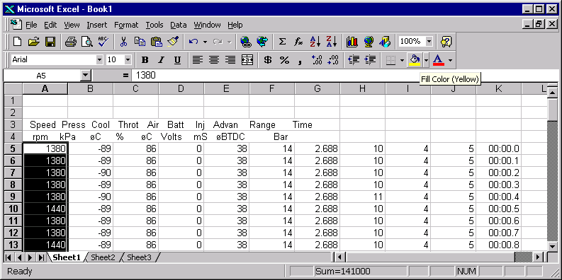
You now have the data separated and are ready to graph. If you know how to graph Excel than you can end here and do what you like. If not, keep going.
Step 9:

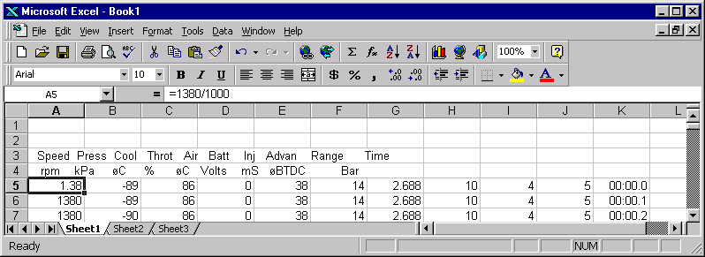
This is the time consuming part. If you want the graph to have a good resolution you will need all of the numbers to be within the same range, i.e. the RPM’s will have to be 10-80 rather than 1000-8000. If they are far off, the smaller numbers like pressure will be a flat line because they are such small numbers compared to the RPM’s. So, now we will have to make all of the columns within the same range. As you can see in the picture in step 8 the RPM’s and temperatures will skew the graph so we need to bring them down to a closer range. Highlight column “B” and then click “Insert” and “Columns” and it will look like this:
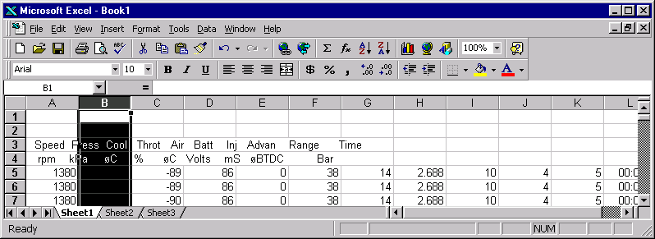
Now highlight the first box in the new empty column after the RPM reading and click the “=” sign. Then use the cursor to choose the box you want the formula to apply to, in the above example it will be A2 because we want the value of A2 to be divided by 100 NOT 1000 to get a smaller number. The click “OK”:
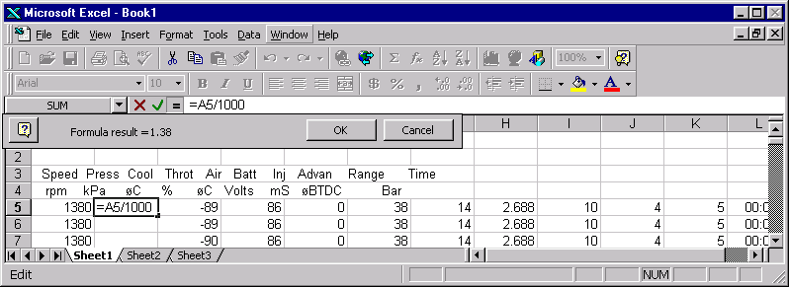
Step 9:

Next we want this formula applied to all of the values so we will extend the box all the way down the current column to the end of the values.:
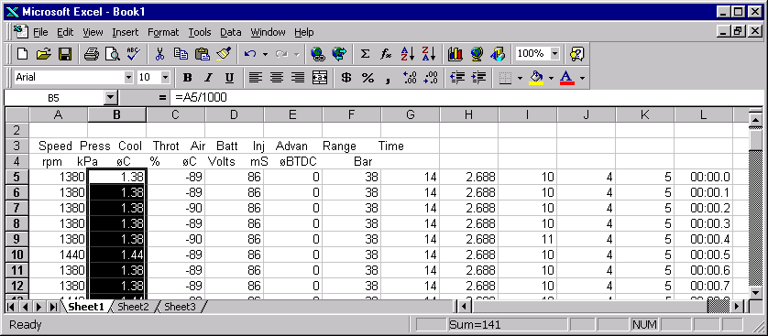
To drag the box you will want to click and hold the small box in the corner of the cell. You should end up with something that looks like the above picture. We now have the RPM reading close to the other values. You will now need to do the same process as Step 9 for the temperatures except divide them by 10 rather than 1000. The end result should look like this:
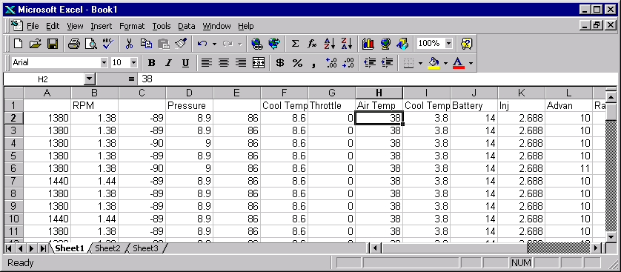
As you can see, I named the columns so I know what is what. Now you will want to hide the columns you will not use. Highlight one, in this case “A”, and then click “Format”, “Column”, “Hide” and then it will disappear. Do this for all of the columns you do not want to graph, like battery, range, bar, or whatever. Here is the end result:
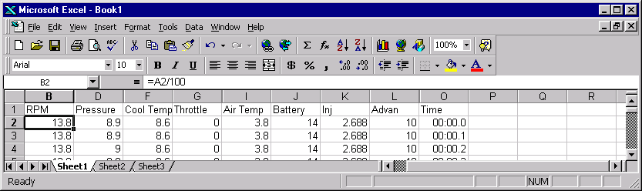
Step 10:

Now it is time to graph. First highlight the first box in “A1” all the way down to the last box, in this case “O76”:
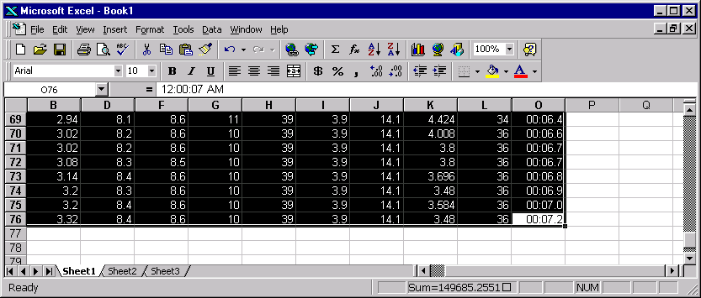
Now click “Insert” then “Chart.” You will get the chart wizard below and then choose the graph below. You can choose all kinds of graphs but this will be the best one:
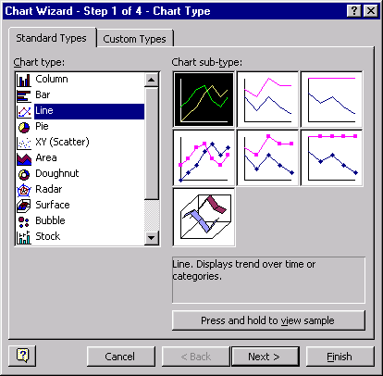
Now click “Next.”
You will see the next choice and it should look like this:
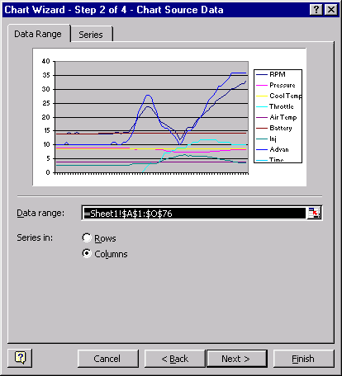
Now click on the “Series” tab near the top and you will see this:
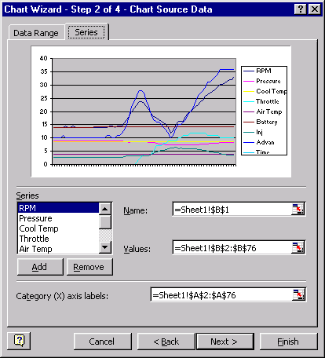
Now click on the little Calendar looking thing to the right of the box in the “Category (X) axis labels:” and you will see this:
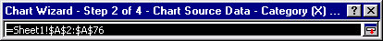
This little box will be in the foreground of the main window. Highlight only the numbers in the “Time” column:
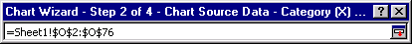
I can’t show the pic of the main window but as you can see from the numbers in the box above I have chose “O2” through “O76” which is all of the numbers in the time column. Now you will hit the little calendar looking box once again to return to the graph section:
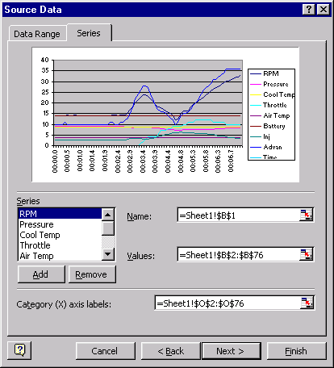
What we have done, as you can see at the bottom of the graph, is to designate the time as the X-axis. Now click “Next.”

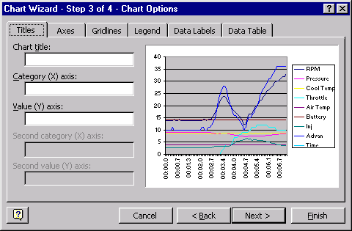
Enter in the name of the X-axis as “Time (seconds)” or whatever you want it to be, as well as the title. Since the Y-axis has many meanings you can leave it blank and then click “Next.”
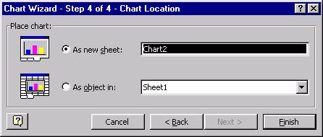
Now choose “As new sheet:” and then click “Finish.” You should get an end result looking like this:
